**Data Preparation/Feature Engineering**

**1. Overview**

The project focuses on predicting target of terrorist attacks using the Global Terrorism Database (GTD). Beginning with data collection, the dataset underwent comprehensive cleaning operations, including the visualization of missing values, handling of data quality issues, and normalization. Exploratory data analysis revealed distribution patterns and identified feature correlations, guiding subsequent decisions in the presence of outliers. Feature engineering incorporated creating new features and transforming existing ones to improve model performance. Data transformation included scaling, normalization, and encoding of features. The project's holistic approach integrates data exploration, cleaning, feature engineering, and transformation, laying the groundwork for robust machine learning model development with potential applications in the relevant domain.

**2. Data Collection**

The Global Terrorism Database (GTD) documents terrorist attacks worldwide from 1970 to the present, with the most recent data available up to June 2021. Previously missing data from 1993 has been added with the help of experts and academics, bringing the total number of recorded incidents to more than 20,000. These incidents span across all continents and countries. The GTD is known for its comprehensive and reliable data. It includes 135 attributes for each entry, covering various aspects such as country, year, casualties, and weapons used. Of these, 46 fields are at least 70% complete. In this project GTD is used and for training a predictive model for Afghanistan only the data related to the country is extracted which contains 20,374 incidents from 1973 until June 2021.

**3. Data Cleaning**

The dataset includes 135 attributes for each entry, covering various aspects such as country, year, casualties, and weapons used. Of these, 46 fields are at least 70% complete.

Numeric variables in the dataset include event ID (eventid), year (iyear), month (imonth), day (iday), latitude (latitude), longitude (longitude), number of deaths (nkill), number of injuries (nwound), and property damage value (propvalue). Text variables cover details like province/state (provstate), city (city), location description (location), criminal group name (gname), and specific target/victim (target1).

The main categorical variables include criteria for inclusion (crit1, crit2, crit3), suspected terrorism (doubtterr), first suspected criminal group (guncertain1), country (country), region (region), type of attack (attacktype1), type of weapon (weapontype1), type of target/victim (targtype1), success of the attack (success), suicide attack (suicide), responsibility claimed (claimed), method of claim (claimedmode), property damage (property), and extent of property damage (propextent).

Data cleansing involved removing attributes with more than 50% missing values. Following the guidelines in the Global Terrorism Database Guidance Manual, we filled the missing values in specific attributes with the appropriate corresponding values. As an example, the “claimmode” attribute’s missing values filled with 9, which 9 is coded as other in Codebook of GTD. For the numerical attributes except “claimmode” missing values were filled with median of the attribute. Also, missing values in categorical columns filled with 'Unknown' according the GTD Codebook.

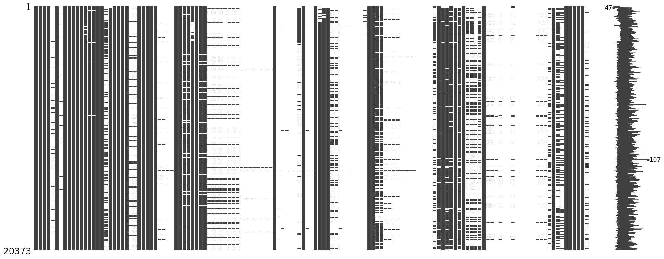**Figure1**: matrix visualization of the missing values in the dataset

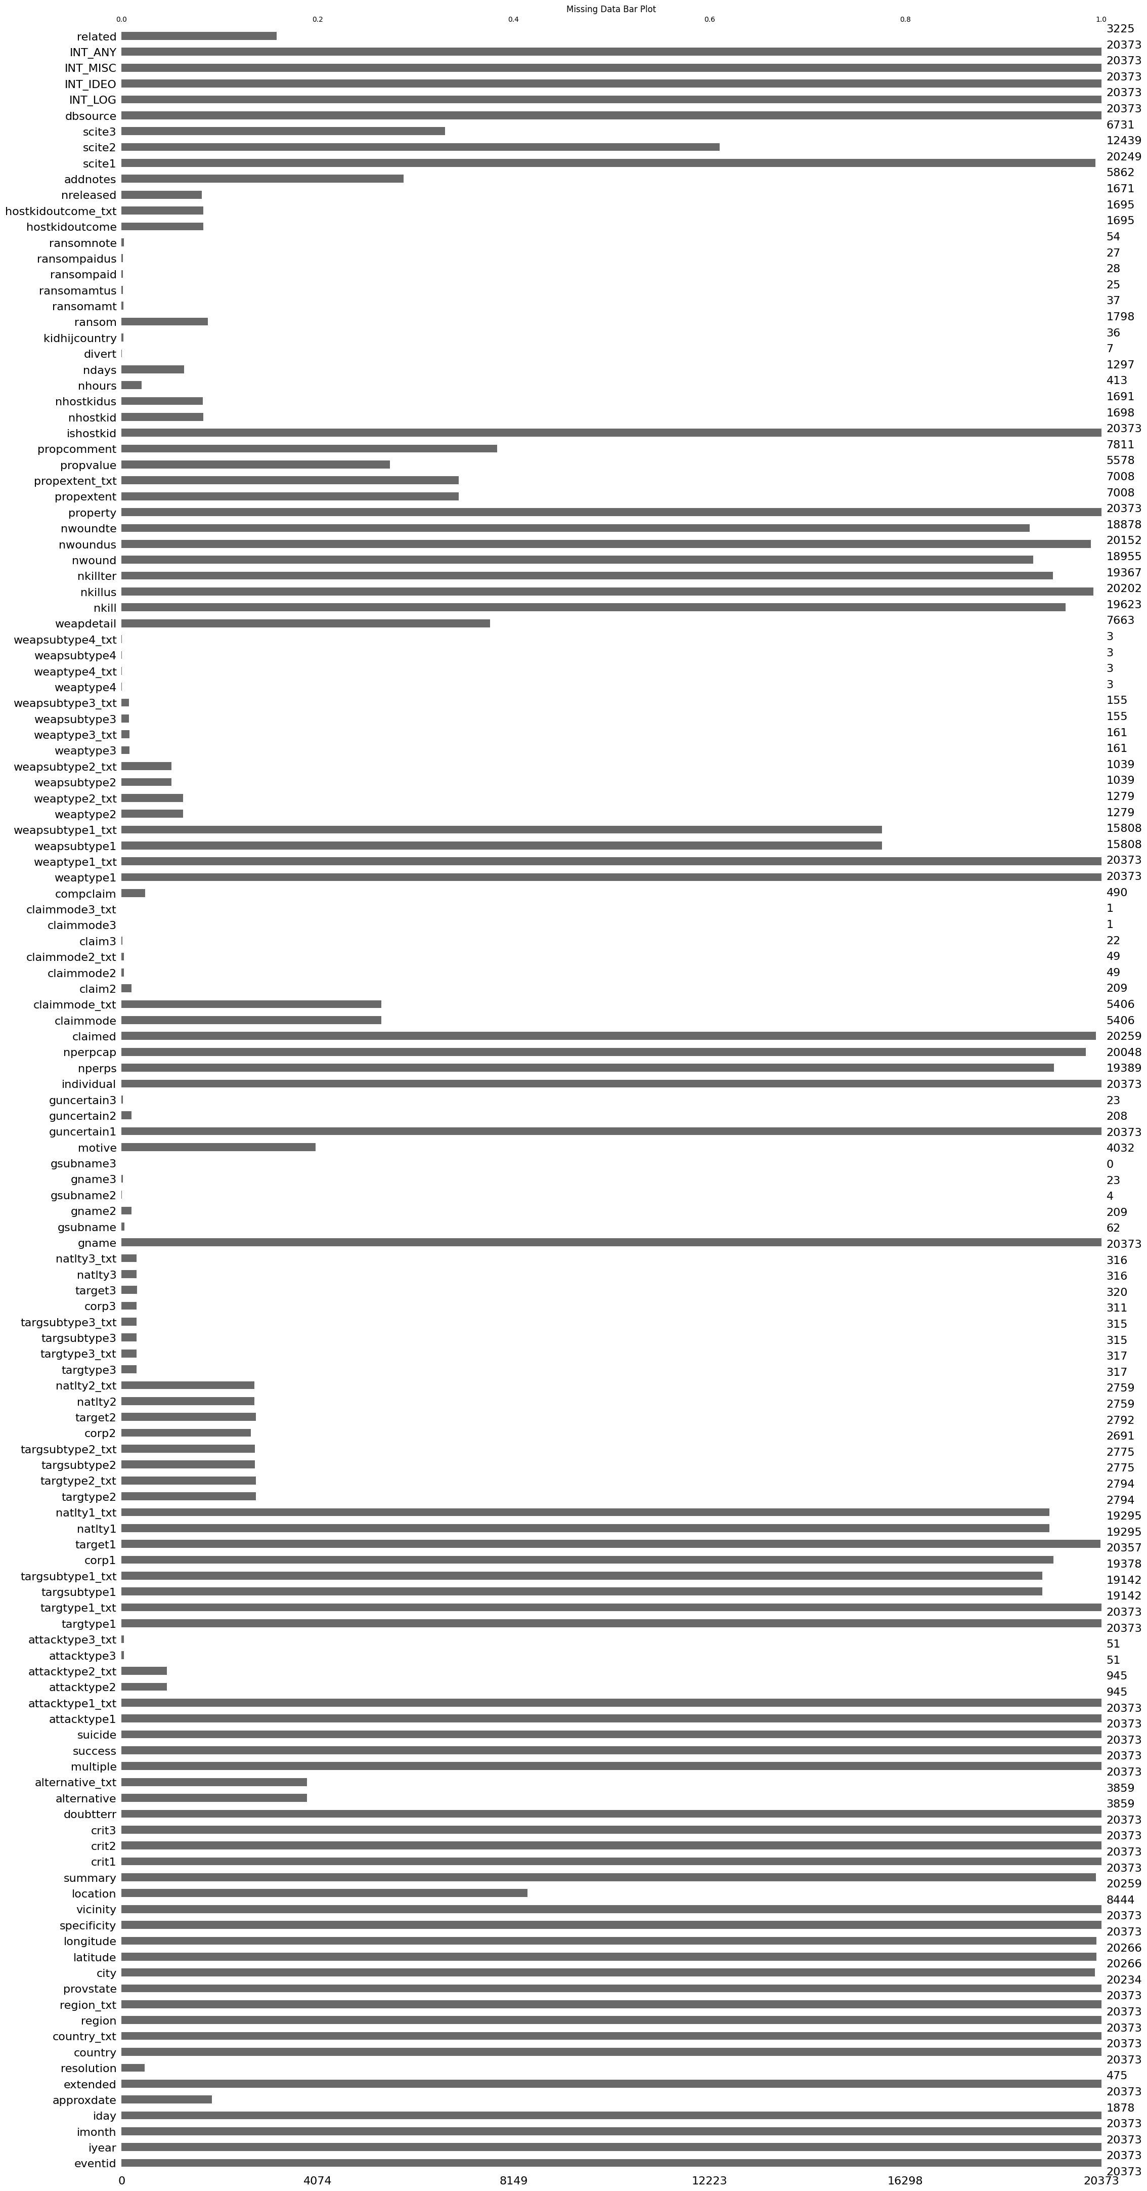**Figure 2**: Missing values bar plot

**4. Exploratory Data Analysis (EDA)**

After EDA, I have found out that most our dataset’s features are normally distributed. But some normalization needs to be done for longitude, latitude, fatalities, and injuries.

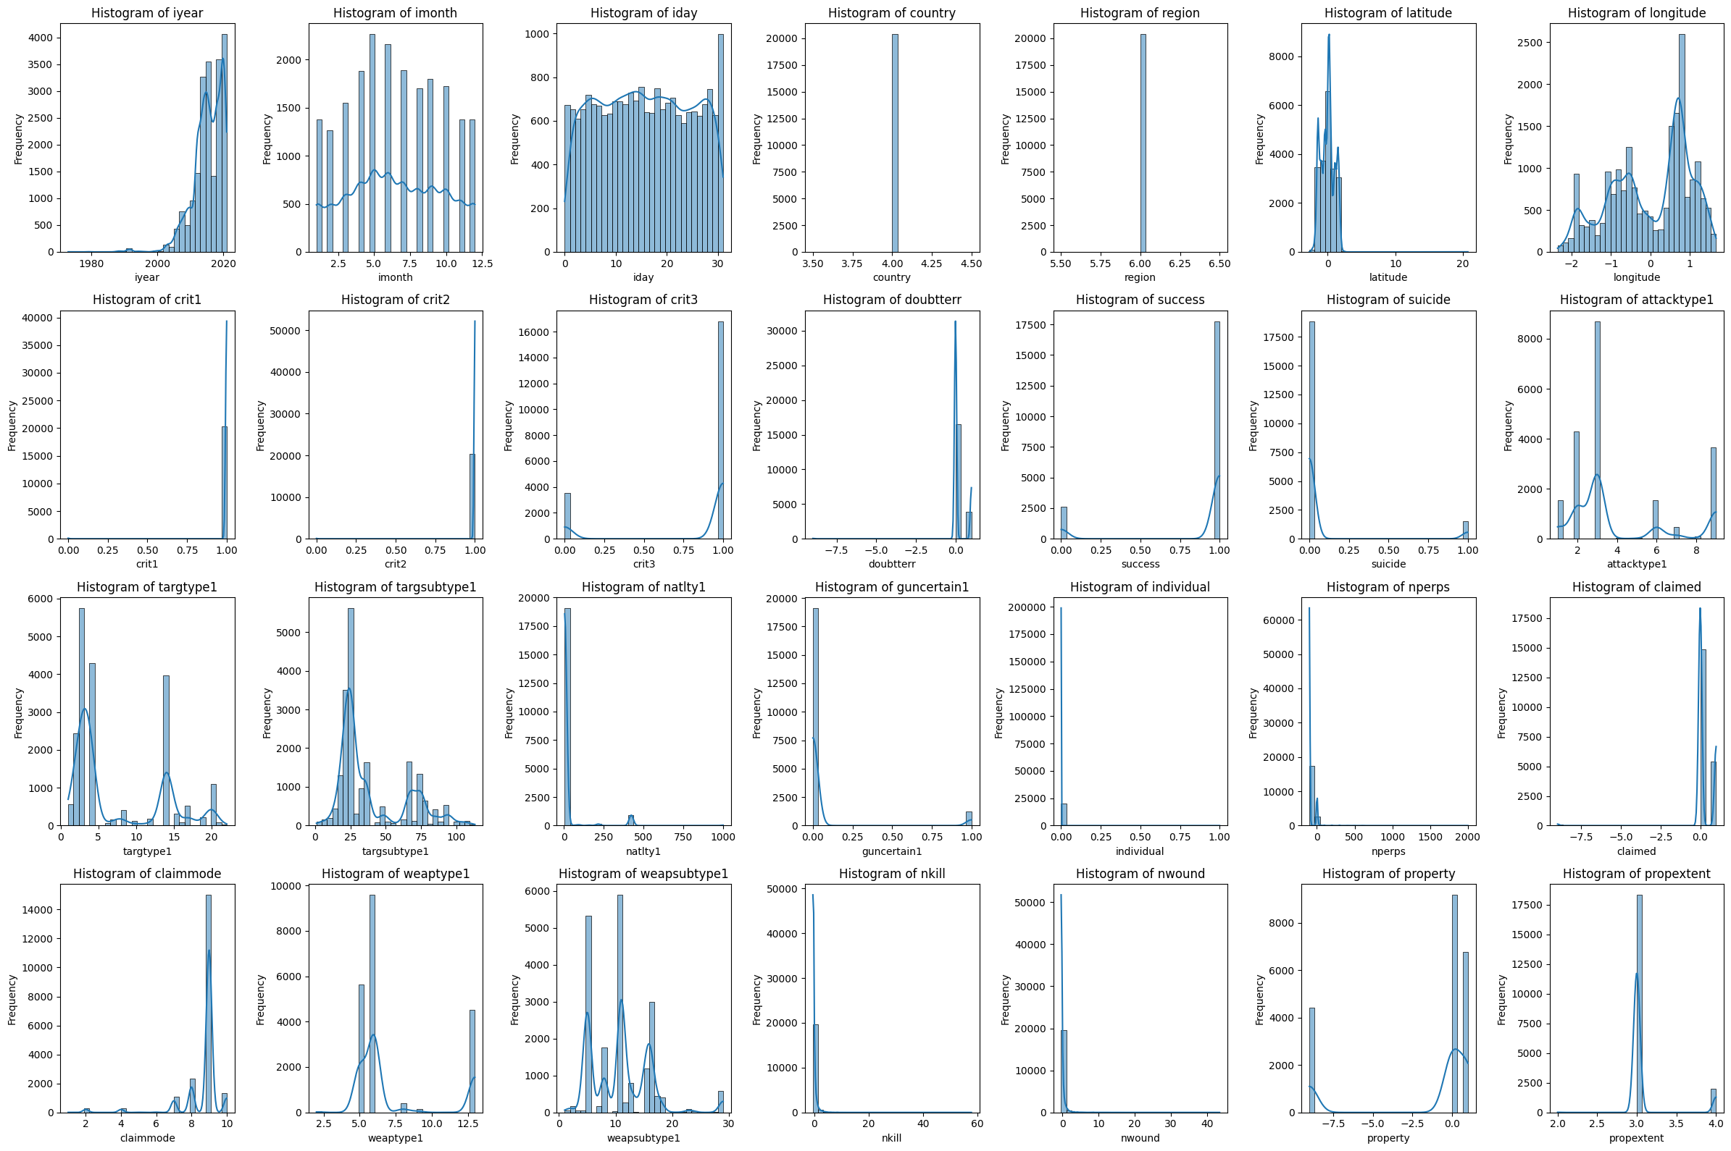 **Figure 3:** Distribution of features of the dataset.

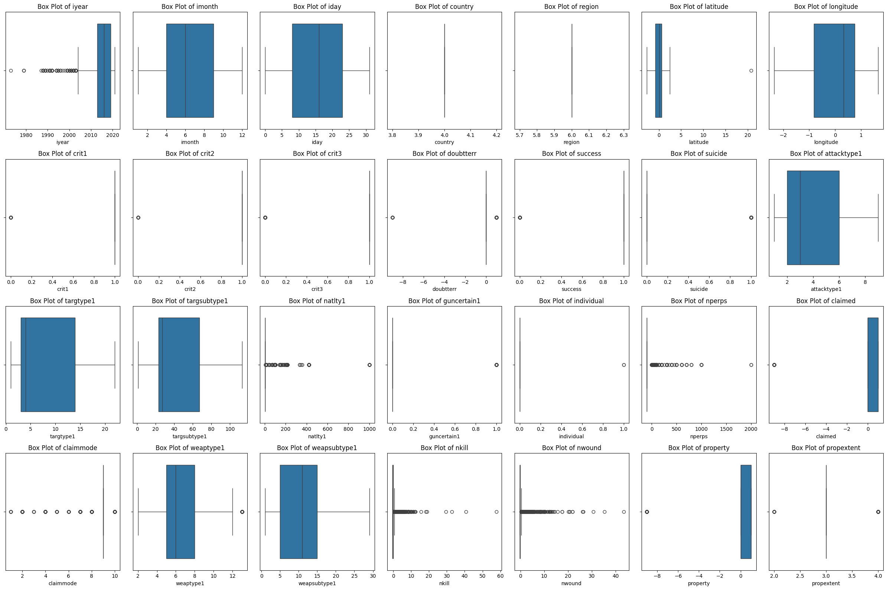 **Figure 4:** Outliers in the dataset.

The correlations between attribute fields are analyzed using methods such as covariance correlation, Pearson correlation, and Kendall correlation. So, I figured out that the country and region are constant can be removed from the dataset.

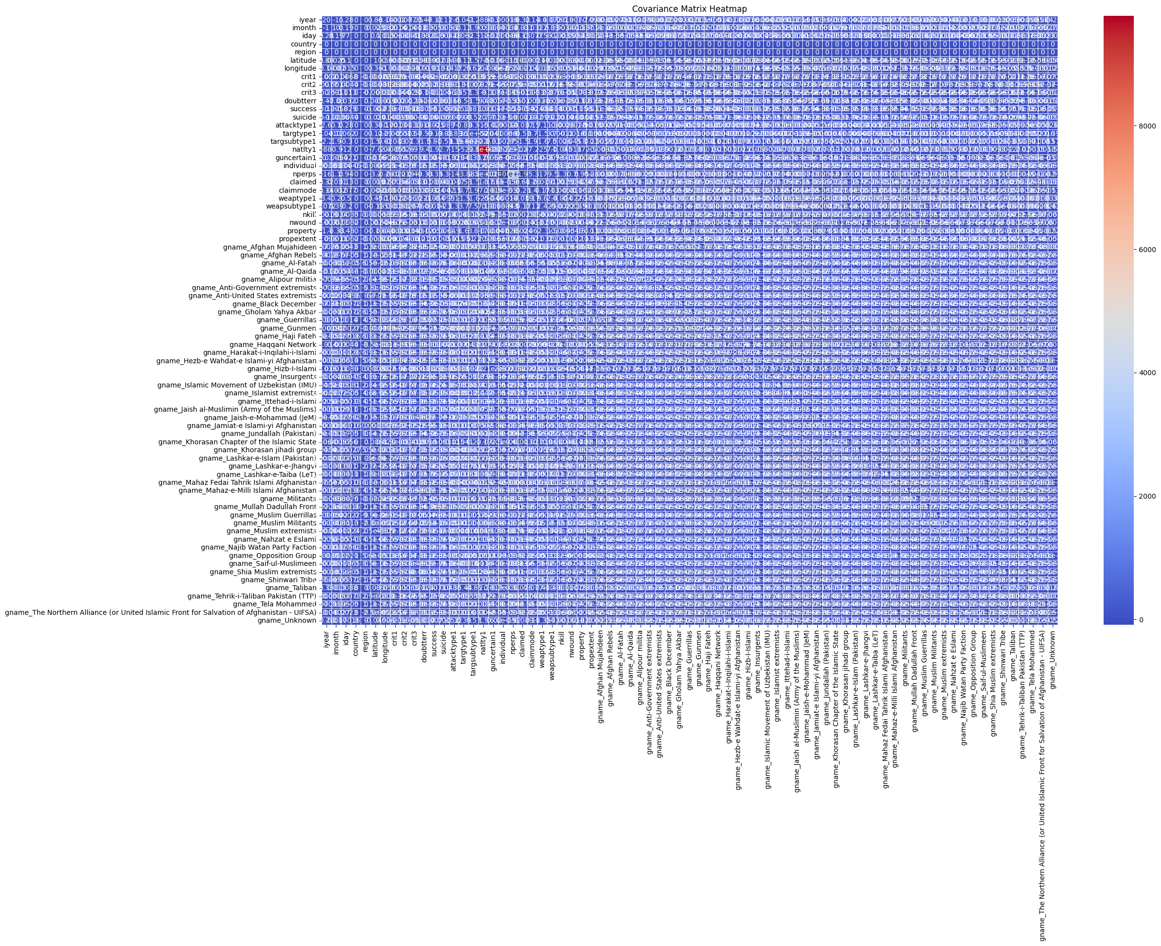 **Figure 5:** covariance matrix heatmap.

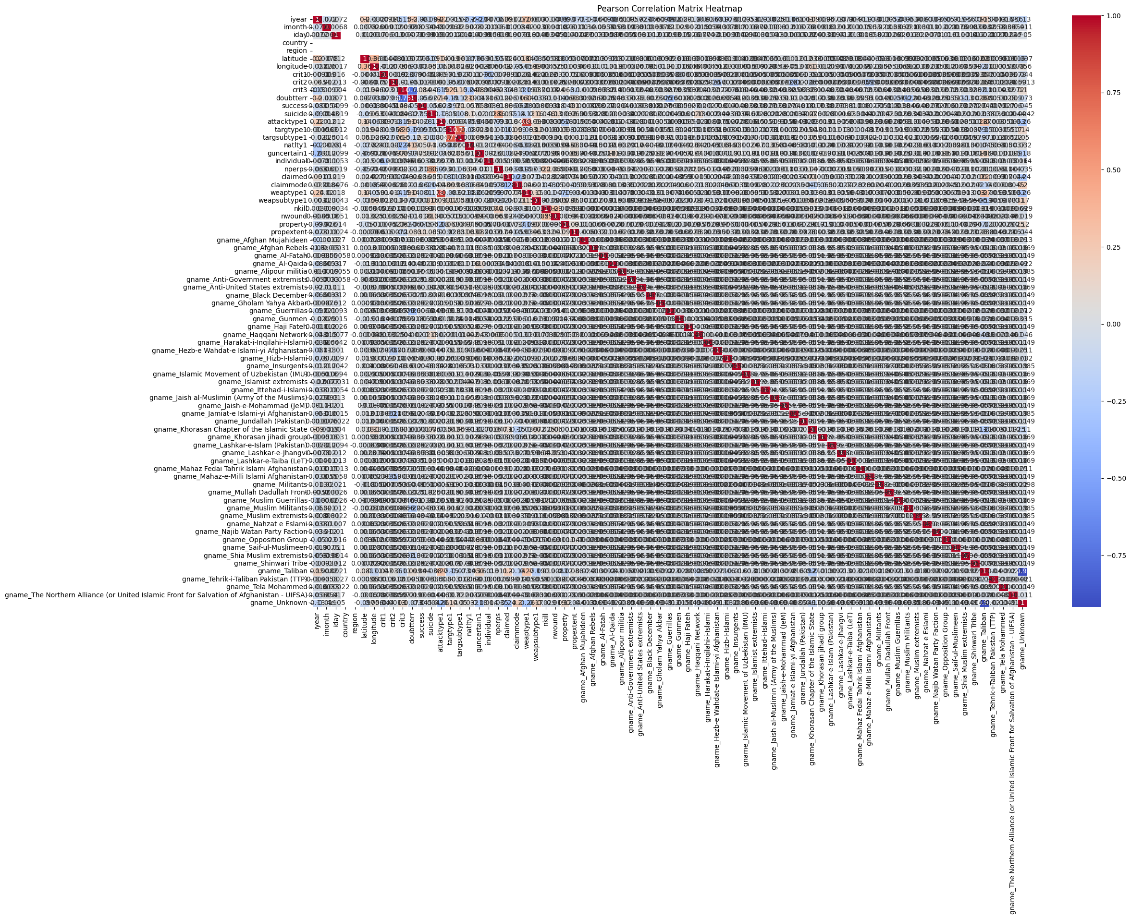 **Figure 6:** Pearson correlation matrix heatmap.

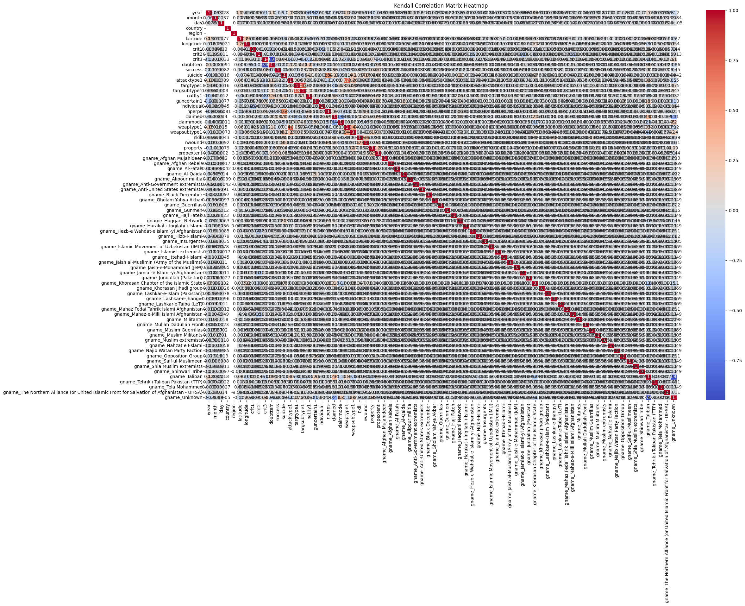 **Figure 6:** Kendall correlation matrix heatmap.

**5. Feature Engineering**

The correlations between the attribute fields were analyzed, using covariance correlation, Pearson correlation and Kendall correlation. In this project, I use a new SelectKBest method in scikit learn to select best 10 features.

from sklearn.feature_selection import SelectKBest, f_classif, f_regression

from sklearn.preprocessing import StandardScaler

from sklearn.model_selection import train_test_split

# Define your target variable and feature set

target_variable = 'targtype1'

X = data_final.drop(columns=[target_variable])

y = data_final[target_variable]

# Split the data into training and testing sets

X_train, X_test, y_train, y_test = train_test_split(X, y, test_size=0.2, random_state=42)

# SelectKBest Feature Selection

k = 10

selector = SelectKBest(score_func=f_classif, k=k)

X_new = selector.fit_transform(X_train, y_train)

# Get the selected feature names

selected_features = X.columns[selector.get_support()]

**6. Data Transformation**

I standardize four features, i.e., longitude, latitude, fatalities, and injuries, by the StandardScaler object method.

# Data normalization

from sklearn.preprocessing import StandardScaler

# Standardize features

features_to_normalize = ['longitude', 'latitude', 'nkill', 'nwound']

scaler = StandardScaler()

data_final[features_to_normalize] = scaler.fit_transform(data_final[features_to_normalize])

I performed type conversion and feature transformation to prepare our data for machine learning models. Specifically, we apply one-hot encoding to categorical features and equal-width binning to numerical features.

One-Hot Encoding for Categorical Features:

Categorical variables in the dataset, typically represented as strings or objects, need to be converted into a numerical format that machine learning algorithms can process. One-hot encoding is used for this purpose. It converts categorical variables into a series of binary columns (0s and 1s), each representing a unique category.

Equal-Width Binning for Numerical Features:

Numerical features can benefit from binning, which groups continuous values into discrete intervals or bins. This can help in reducing the effect of noise and outliers and can sometimes improve the performance of certain algorithms.

#type conversion

from sklearn.preprocessing import OneHotEncoder, KBinsDiscretizer

# One-hot encoding for categorical features

categorical_columns = data_final.select_dtypes(include=['object']).columns

data_final = pd.get_dummies(data_final, columns=categorical_columns, drop_first=True)

# Equal-width binning for numerical features (Example: 'nkill', 'nwound')

binning_columns = ['nkill', 'nwound']

kbin = KBinsDiscretizer(n_bins=10, encode='ordinal', strategy='uniform')

data_final[binning_columns] = kbin.fit_transform(data_final[binning_columns])

**Model Exploration**

**1. Model Selection**

The following models were explored for this project:

* Support Vector Machines (SVM)
* Decision Trees
* k-Nearest Neighbors (KNN)
* Deep Neural Networks (DNN)

Support Vector Machines (SVM):

Rationale:

SVM is well-suited for high-dimensional spaces and applicable to both classification and regression tasks. It is particularly effective when the number of features exceeds the number of samples.

Strengths:

Effective in High-Dimensional Spaces: SVM excels in scenarios with more features than observations.

Robust to Overfitting: The regularization parameter helps SVM avoid overfitting, particularly in high-dimensional spaces.

Margin Optimization: Maximizes the margin between classes, often leading to better generalization.

Weaknesses:

Computational Complexity: Training SVM can be computationally intensive, especially with large datasets.

Memory Usage: The algorithm can consume significant memory.

Parameter Sensitivity: Requires careful tuning of parameters like the regularization parameter and kernel choice.

Decision Trees:

Rationale:

Decision Trees are versatile for both classification and regression tasks.

They capture nonlinear relationships and interactions between features and are highly interpretable.

Strengths:

Interpretability: Provide a transparent, easy-to-understand decision-making structure.

Handles Mixed Data Types: Suitable for both numerical and categorical features.

Feature Importance: Easily identifies key features.

Weaknesses:

Overfitting: Prone to overfitting, particularly with noisy data.

Instability: Small changes in the data can result in different tree structures.

k-Nearest Neighbors (KNN):

Rationale:

KNN is a non-parametric, instance-based algorithm suitable for both classification and regression.

Simple to understand and implement, with no training phase required.

Strengths:

Nonlinearity: Capable of modeling complex relationships without assuming linearity.

No Training Phase: Uses the entire training dataset during prediction.

Weaknesses:

Computational Complexity: Slow prediction time, especially for large datasets.

Sensitivity to Noise and Outliers: Can be affected by noisy or irrelevant features.

Memory Usage: Requires storing the entire dataset, which can be memory intensive.

Deep Neural Networks (DNN):

Rationale:

DNNs are powerful models capable of learning complex relationships in data.

Suitable for tasks with large datasets and intricate patterns.

Strengths:

Nonlinearity: Can capture highly nonlinear relationships.

Representation Learning: Automatically learns hierarchical representations of features.

Versatility: Applicable to a wide range of tasks, including classification and regression.

Weaknesses:

Complexity: Training and tuning can be computationally intensive.

Requires Sufficient Data: Needs large amounts of data to avoid overfitting.

Interpretability: Often considered black-box models, making interpretation challenging.

**Model Training**

Each model was trained on the dataset. The models were evaluated based on accuracy, precision, recall, and F1 score.

**Support Vector Machines (SVM):**

SVM Model Accuracy: 0.9742331288343559

SVM Classification Report:

precision recall f1-score support

1 0.97 0.86 0.91 132

2 1.00 0.98 0.99 492

3 0.99 1.00 0.99 1110

4 0.99 0.99 0.99 904

6 0.93 0.76 0.84 17

7 1.00 0.77 0.87 35

8 1.00 0.97 0.99 79

9 1.00 0.50 0.67 2

10 0.94 0.80 0.86 20

11 0.00 0.00 0.00 1

12 0.97 0.76 0.85 37

13 0.00 0.00 0.00 1

14 0.93 0.99 0.96 770

15 1.00 0.89 0.94 61

16 1.00 0.94 0.97 17

17 1.00 0.99 1.00 119

18 0.00 0.00 0.00 1

19 1.00 0.94 0.97 47

20 0.92 0.95 0.93 208

21 1.00 1.00 1.00 17

22 1.00 0.80 0.89 5

accuracy 0.97 4075

macro avg 0.84 0.76 0.79 4075

weighted avg 0.97 0.97 0.97 4075

**Decision Tree:**

Decision Tree Model Accuracy: 0.9901840490797545

Decision Tree Classification Report:

precision recall f1-score support

1 0.97 0.96 0.97 132

2 1.00 1.00 1.00 492

3 1.00 1.00 1.00 1110

4 1.00 0.98 0.99 904

6 1.00 1.00 1.00 17

7 1.00 0.94 0.97 35

8 0.99 0.99 0.99 79

9 1.00 1.00 1.00 2

10 0.87 1.00 0.93 20

11 1.00 1.00 1.00 1

12 0.95 1.00 0.97 37

13 1.00 1.00 1.00 1

14 0.99 0.99 0.99 770

15 1.00 0.97 0.98 61

16 1.00 1.00 1.00 17

17 1.00 1.00 1.00 119

18 0.50 1.00 0.67 1

19 1.00 1.00 1.00 47

20 0.93 0.96 0.94 208

21 1.00 1.00 1.00 17

22 1.00 1.00 1.00 5

accuracy 0.99 4075

macro avg 0.96 0.99 0.97 4075

weighted avg 0.99 0.99 0.99 4075

**KNN:**

KNN Model Accuracy: 0.9754601226993865

KNN Classification Report:

precision recall f1-score support

1 0.91 0.92 0.92 132

2 0.98 0.98 0.98 492

3 0.99 0.99 0.99 1110

4 0.99 0.98 0.99 904

6 0.93 0.76 0.84 17

7 0.79 0.89 0.84 35

8 0.96 0.97 0.97 79

9 0.50 0.50 0.50 2

10 0.75 0.75 0.75 20

11 0.00 0.00 0.00 1

12 0.86 0.84 0.85 37

13 0.00 0.00 0.00 1

14 0.98 0.99 0.99 770

15 0.95 0.85 0.90 61

16 0.94 1.00 0.97 17

17 1.00 0.99 1.00 119

18 0.00 0.00 0.00 1

19 0.98 1.00 0.99 47

20 0.92 0.96 0.94 208

21 1.00 0.94 0.97 17

22 0.83 1.00 0.91 5

accuracy 0.98 4075

macro avg 0.77 0.78 0.78 4075

weighted avg 0.98 0.98 0.98 4075

**Neural Network:**

Neural Network Model Accuracy: 0.889079754601227

Neural Network Classification Report:

precision recall f1-score support

1 0.95 0.68 0.79 132

2 0.92 0.89 0.91 492

3 0.89 0.98 0.93 1110

4 0.97 0.93 0.95 904

6 0.00 0.00 0.00 17

7 0.69 0.77 0.73 35

8 0.93 0.95 0.94 79

9 0.00 0.00 0.00 2

10 0.00 0.00 0.00 20

11 0.00 0.00 0.00 1

12 0.75 0.41 0.53 37

13 0.00 0.00 0.00 1

14 0.94 0.97 0.95 770

15 0.67 0.69 0.68 61

16 0.00 0.00 0.00 17

17 0.88 0.55 0.67 119

18 0.00 0.00 0.00 1

19 0.37 1.00 0.54 47

20 0.71 0.75 0.73 208

21 0.33 0.06 0.10 17

22 0.00 0.00 0.00 5

accuracy 0.89 4075

macro avg 0.48 0.46 0.45 4075

weighted avg 0.88 0.89 0.88 4075

Based on the evaluation metrics, the top-performing models were SVM and Decision Trees. Considering the dataset size and the need for interpretability, we selected the Decision Trees model. Despite SVM's slightly lower accuracy, Decision Trees effectiveness in high-dimensional spaces and better generalization made it the preferred choice for this project.

**3. Model Evaluation**

Confusion matrix:

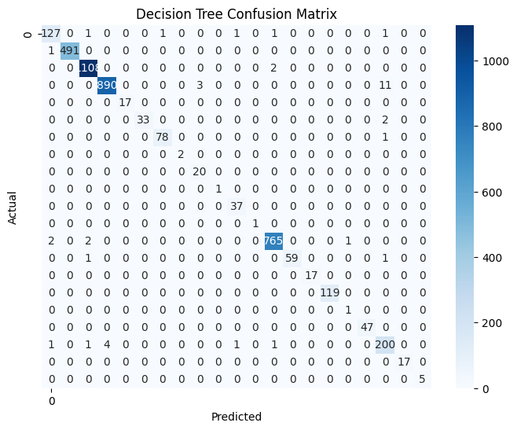

Roc curve for each class:

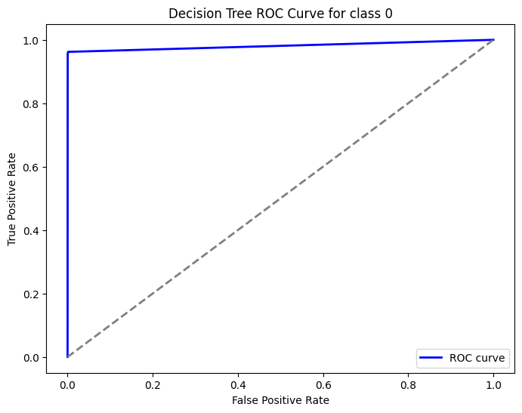

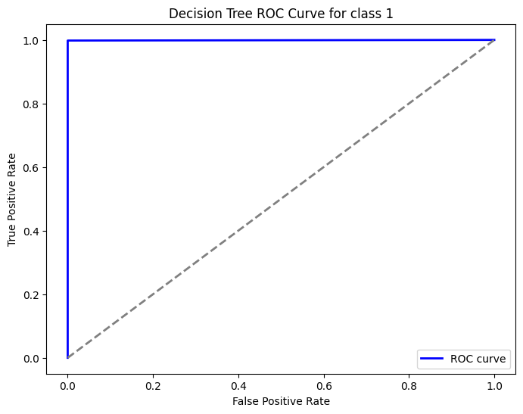

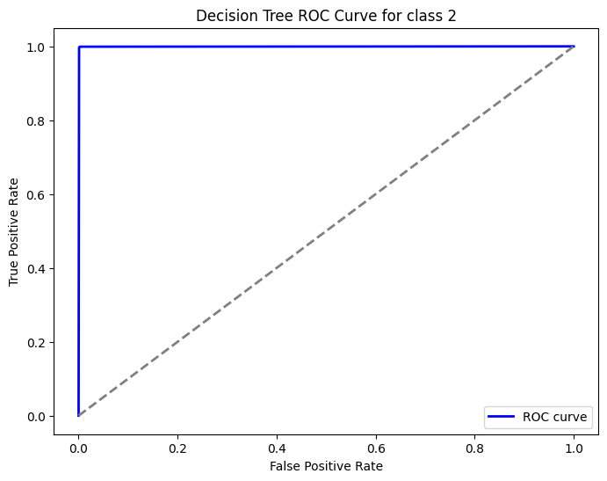

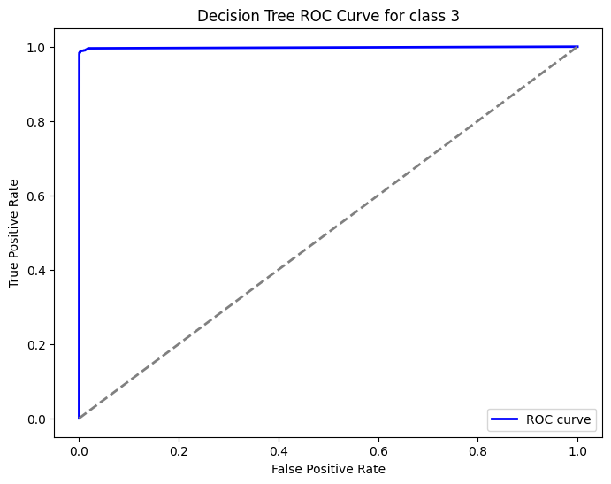

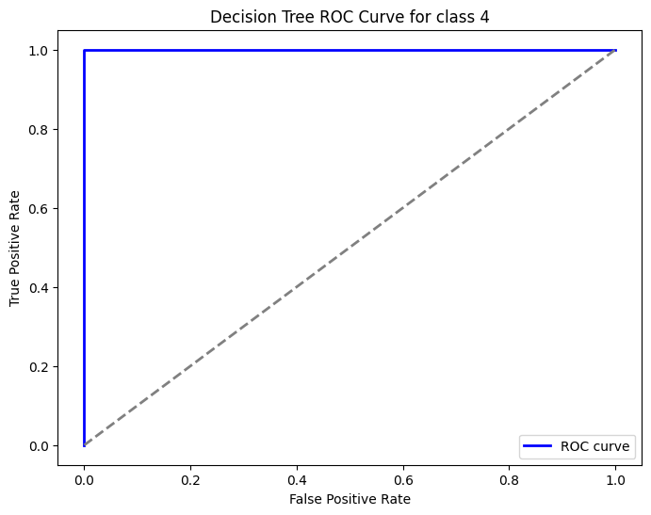

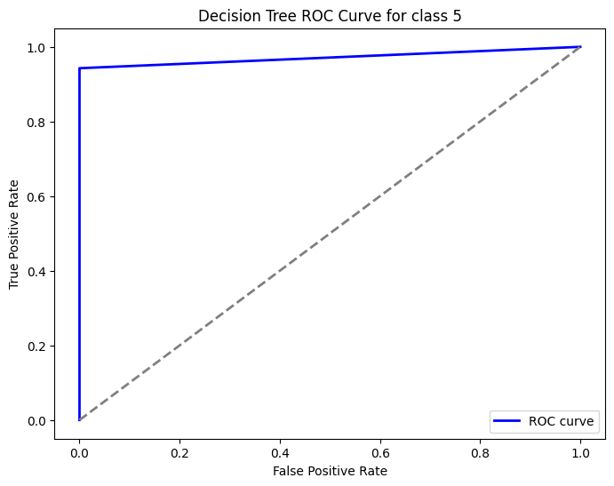

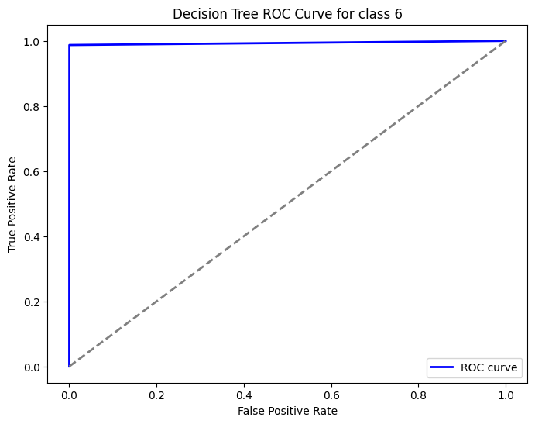

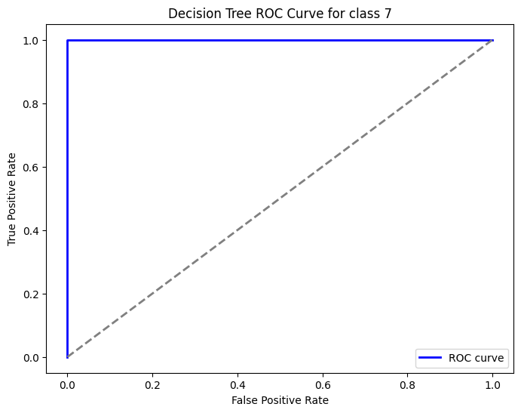

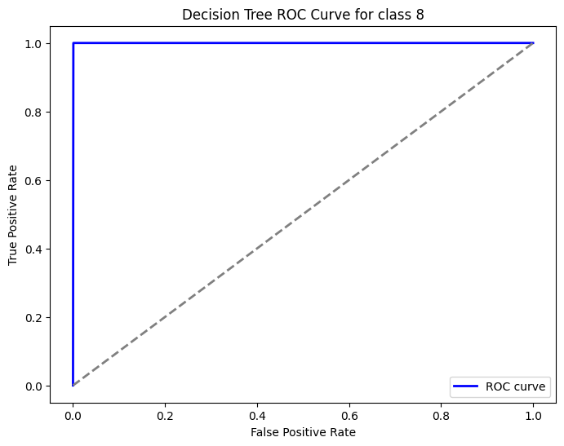

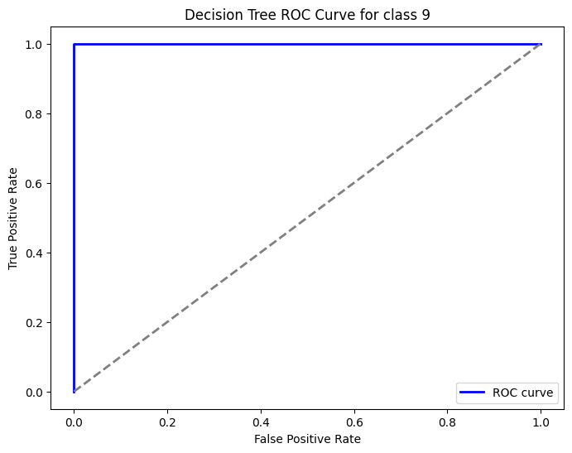

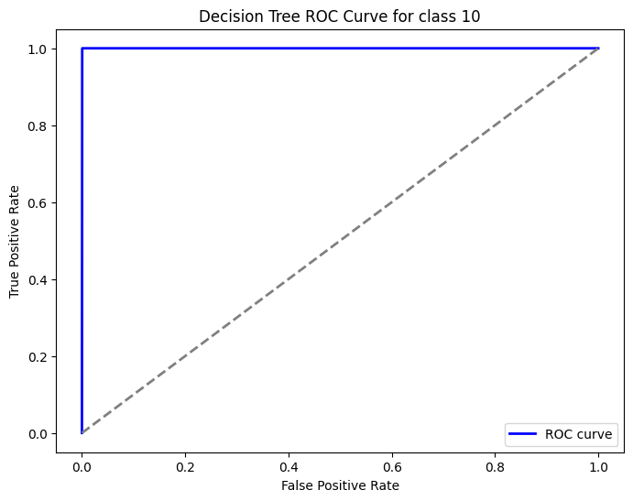

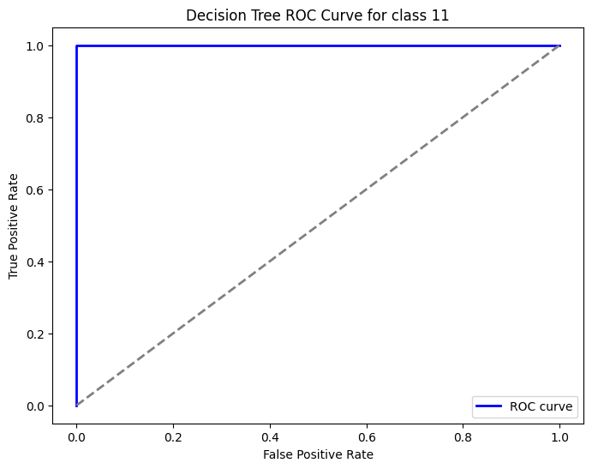

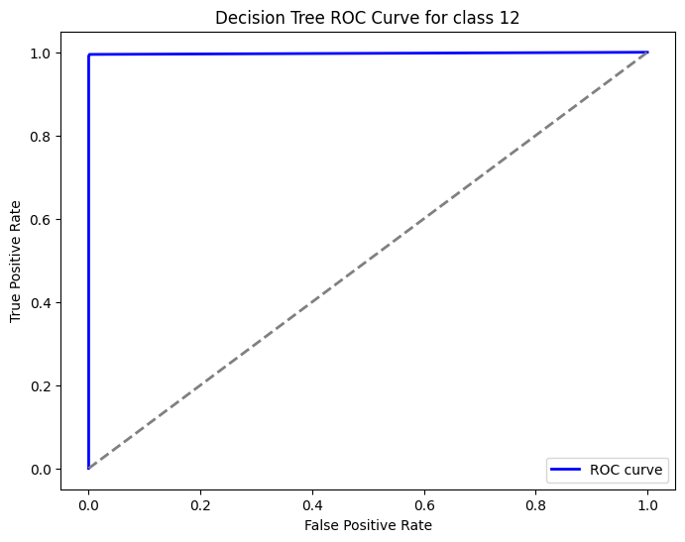

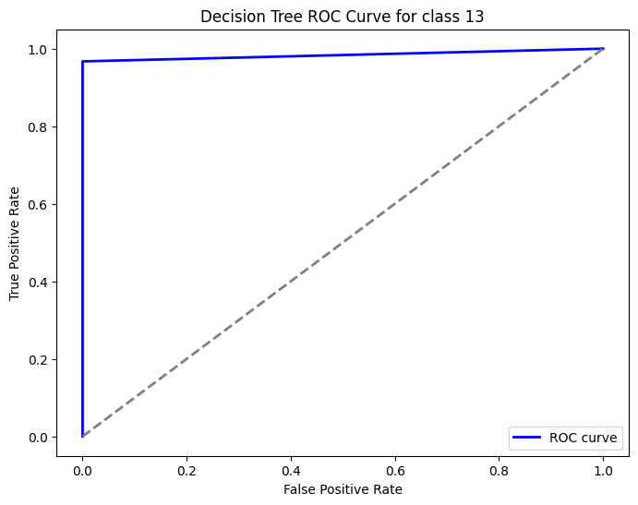

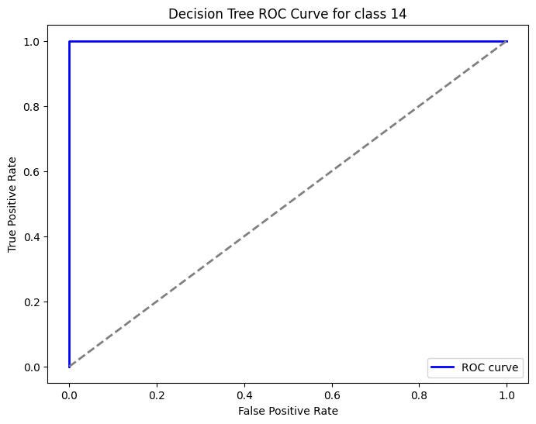

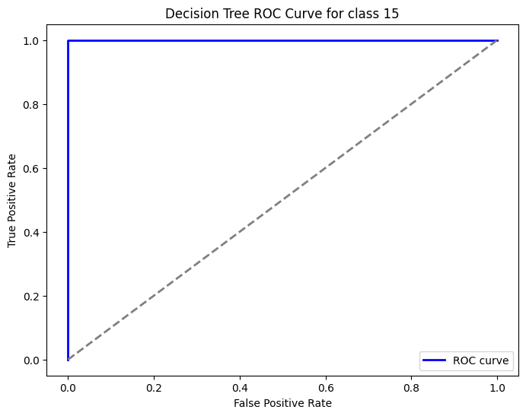

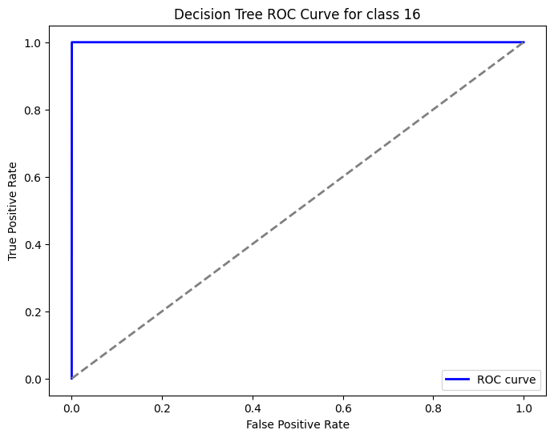

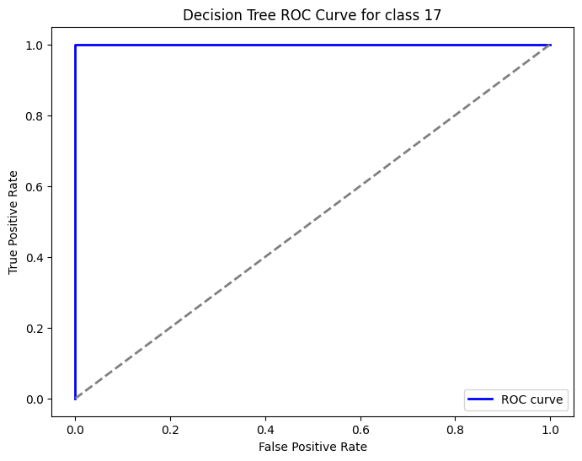

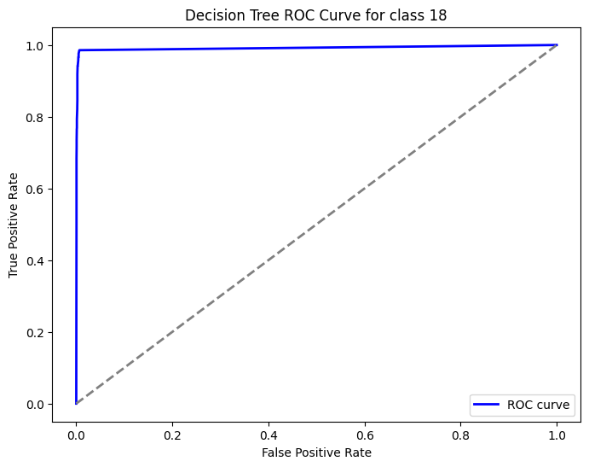

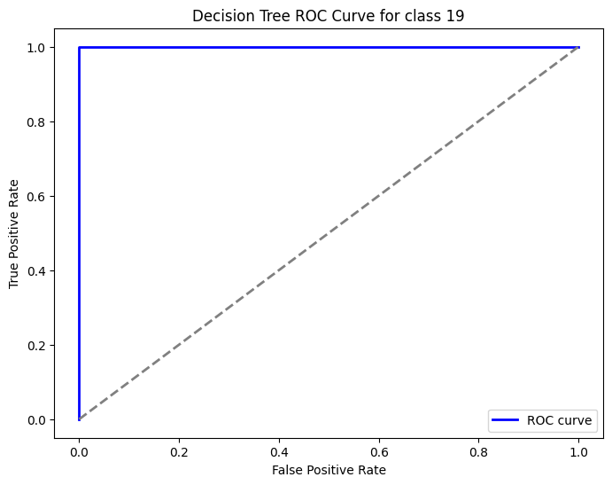

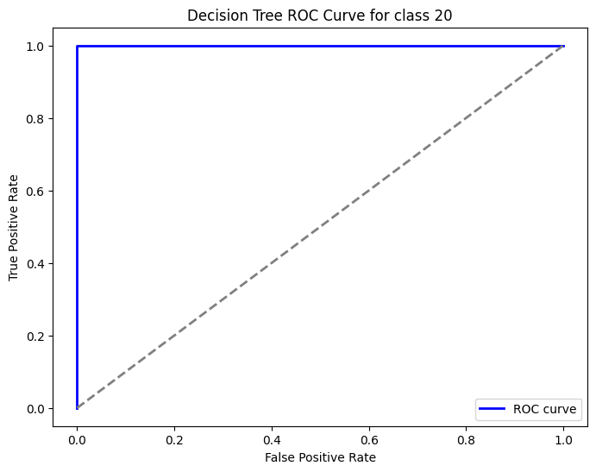

**4. Code Implementation**

# Calculate the percentage of missing values for each column

missing_values_percent = (df.isnull().sum() / len(df)) * 100

# Display columns with their respective missing values percentage

print(missing_values_percent.sort_values(ascending=False))

# Identify columns with more than 50% missing values

high_missing_columns = missing_values_percent[missing_values_percent > 50].index.tolist()

print(f"Columns with more than 50% missing values: {high_missing_columns}")

new_df = df

# drop columns with more than 50% missing values

data_selected = new_df.drop(columns= high_missing_columns)

# Calculate the percentage of missing values for each column

missing_values_percent = (data_selected.isnull().sum() / len(data_selected)) * 100

# Display columns with their respective missing values percentage

print(missing_values_percent.sort_values(ascending=False))

# Fill missing values in numerical columns with median

numerical_columns = ['iyear', 'imonth', 'iday', 'country', 'region', 'latitude', 'longitude',

       'crit1', 'crit2', 'crit3', 'doubtterr', 'success', 'suicide',

       'attacktype1', 'targtype1', 'targsubtype1', 'natlty1', 'guncertain1',

       'individual', 'nperps', 'claimed', 'weaptype1',

       'weapsubtype1', 'nkill', 'nwound', 'property', 'propextent']

for column in numerical_columns:

    data_cleaned[column].fillna(data_cleaned[column].median(), inplace=True)

# Fill missing values in categorical columns with 'Unknown'

categorical_columns = data_cleaned.select_dtypes(include=['object']).columns

for column in categorical_columns:

    data_cleaned[column].fillna('Unknown', inplace=True)

#cheking for null values

data_cleaned.isnull().sum()

# Data normalization

from sklearn.preprocessing import StandardScaler

# Standardize features

features_to_normalize = ['longitude', 'latitude', 'nkill', 'nwound']

scaler = StandardScaler()

data_final[features_to_normalize] = scaler.fit_transform(data_final[features_to_normalize])

print("Data after normalization:")

print(data_final[features_to_normalize].head())

#type conversion

from sklearn.preprocessing import OneHotEncoder, KBinsDiscretizer

# One-hot encoding for categorical features

categorical_columns = data_final.select_dtypes(include=['object']).columns

data_final = pd.get_dummies(data_final, columns=categorical_columns, drop_first=True)

# Equal-width binning for numerical features (Example: 'nkill', 'nwound')

binning_columns = ['nkill', 'nwound']

kbin = KBinsDiscretizer(n_bins=10, encode='ordinal', strategy='uniform')

data_final[binning_columns] = kbin.fit_transform(data_final[binning_columns])

print("Data after type conversion:")

data_final.head()

# Define your target variable and feature set

target_variable = 'targtype1'

X = data_final.drop(columns=[target_variable])

y = data_final[target_variable]

# Split the data into training and testing sets

X_train, X_test, y_train, y_test = train_test_split(X, y, test_size=0.2, random_state=42)

# SelectKBest Feature Selection

k = 10

selector = SelectKBest(score_func=f_classif, k=k)

X_new = selector.fit_transform(X_train, y_train)

# Get the selected feature names

selected_features = X.columns[selector.get_support()]

print("Selected Features:")

print(selected_features)

from sklearn.tree import DecisionTreeClassifier

from sklearn.metrics import accuracy_score

# Train a Decision Tree Classifier using the selected features

model = DecisionTreeClassifier(random_state=42)

model.fit(X_new, y_train)

# Transform the test set using the same selector

X_test_new = selector.transform(X_test)

# Make predictions and evaluate the model

y_pred = model.predict(X_test_new)

accuracy = accuracy_score(y_test, y_pred)

print(f"Model Accuracy: {accuracy:.2f}")